Smart Sorting: Transfer Learning For Identifying Rotten Fruits And Vegetable

1. INTRODUCTION

1.1 Project Overview
Smart Sorting is a Deep Learning-based image classification system designed to identify whether fruits and vegetables are fresh or rotten using Transfer Learning techniques. The system uses pre-trained Convolutional Neural Network (CNN) models and adapts them to classify images accurately. This project aims to automate the quality inspection process in agriculture, supermarkets, and food supply chains.

1.2 Purpose
- The purpose of this project is to:
- Detect rotten fruits and vegetables automatically.
- Reduce manual inspection effort.
- Improve food quality control processes.
- Minimize food wastage using AI-based sorting.

2. IDEATION PHASE

2.1 Problem Statement
Manual sorting of fruits and vegetables in markets and warehouses is time-consuming and prone to human error. Identifying rotten produce accurately requires experience and consistency. There is a need for an automated system that can classify fruits and vegetables as fresh or rotten using image processing and machine learning techniques.

2.2 Empathy Map Canvas
User Thinks:
- Manual inspection is tiring and inconsistent.
- Need faster quality checking system.
User Feels:
- Concerned about selling spoiled products.
- Worried about customer complaints.
User Says:
- “We need a quick sorting solution.”
- “Manual checking takes too much time.”
User Does:
- Inspects fruits manually.
- Removes visibly damaged produce.

2.3 Brainstorming
Possible solutions discussed:
- Rule-based image processing system
- Machine learning classification model
- Deep learning CNN-based classifier
- Transfer Learning using pre-trained models
Final solution selected:
Transfer Learning-based Deep Learning model for image classification.
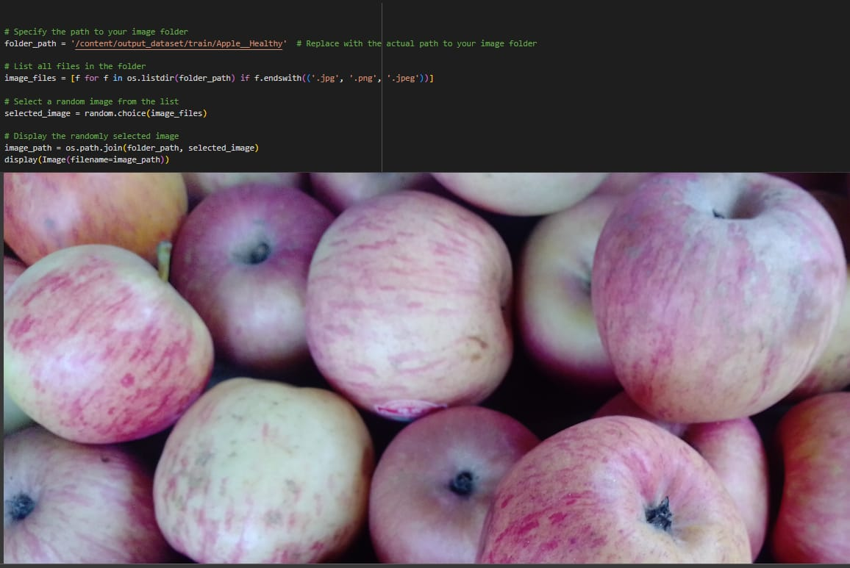
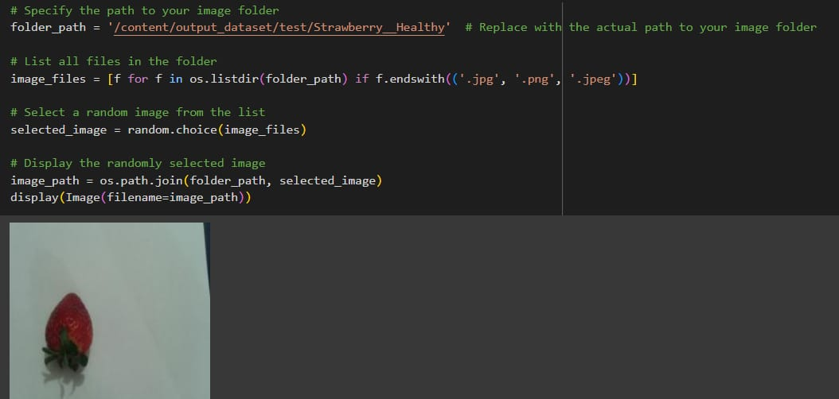
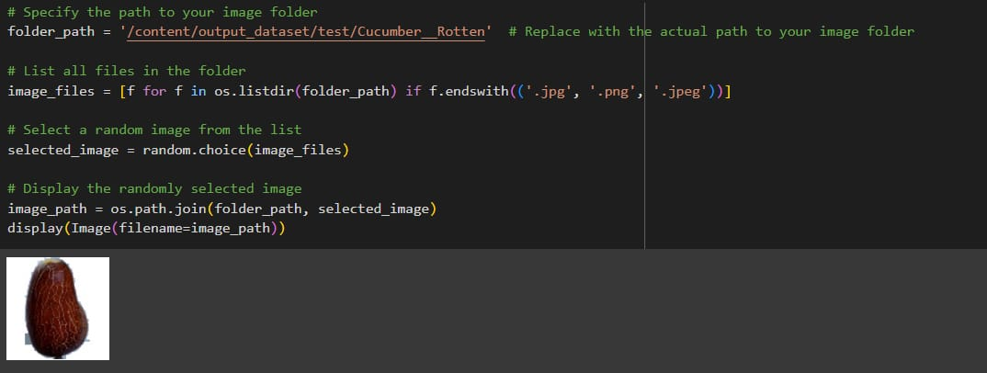
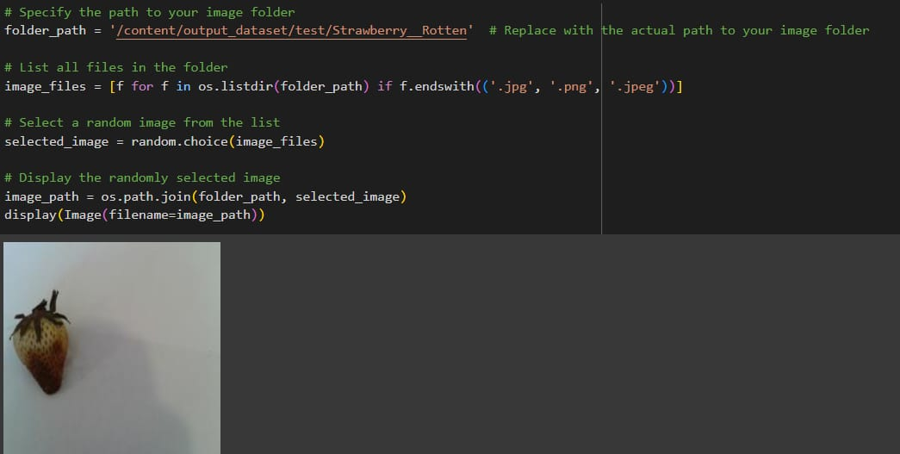

3. REQUIREMENT ANALYSIS

3.1 Customer Journey Map
- User captures/upload image of fruit/vegetable.
- System processes image.
- Model predicts Fresh or Rotten.
- Result displayed to user.
- User takes sorting decision.

3.2 Solution Requirement
Functional Requirements:
- Image upload option.
- Preprocessing of images.
- Transfer Learning-based classification model.
- Display prediction results.
Non-Functional Requirements:
- High accuracy.
- Fast response time.
- Scalable system.
- User-friendly interface.

3.3 Data Flow Diagram
Level 0 (Context Diagram):
User → Smart Sorting System → Fresh/Rotten Result
Level 1:
Image Upload → Image Preprocessing → Transfer Learning Model → Classification → Output Display

3.4 Technology Stack
- Programming Language: Python
- Framework: TensorFlow / Keras / PyTorch
- Pre-trained Models: MobileNet / VGG16 / ResNet50
- Frontend: Streamlit / Flask
- Image Processing: OpenCV
- Deployment: Cloud Platform

4. PROJECT DESIGN

4.1 Problem Solution Fit
The proposed solution effectively addresses the need for automated quality inspection by using Transfer Learning, which reduces training time and improves classification accuracy.

4.2 Proposed Solution
The system uses a pre-trained CNN model and fine-tunes it with a dataset of fruit and vegetable images labeled as fresh or rotten. The trained model predicts the condition of the produce from new input images.

4.3 Solution Architecture
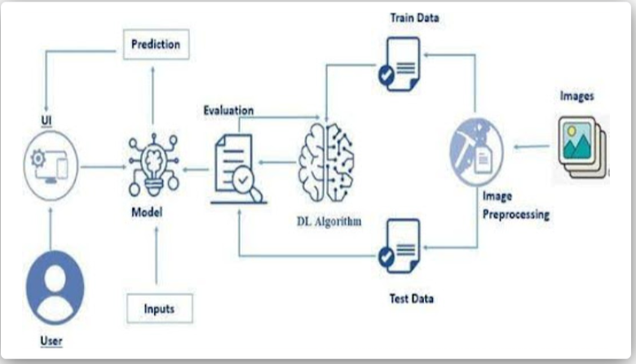

5. PROJECT PLANNING & SCHEDULING

5.1 Project Planning
Phase | Activity | Duration
Phase 1 | Requirement Analysis | 1 Week
Phase 2 | Dataset Collection & Preprocessing | 1 Week
Phase 3 | Model Development | 2 Weeks
Phase 4 | Testing & Evaluation | 1 Week
Phase 5 | Deployment | 1 Week

6. FUNCTIONAL AND PERFORMANCE TESTING

6.1 Performance Testing
- Evaluated model accuracy on test dataset.
- Measured precision, recall, and F1-score.
- Tested with real-time uploaded images.
- Verified classification speed.
Results:
- High classification accuracy.
- Quick response time.
- Reliable predictions under varied lighting conditions.

7. RESULTS

7.1 Output Screenshots
- The system successfully:
- Classifies fruits and vegetables as Fresh or Rotten.
- Displays prediction probability.
- Processes images efficiently.
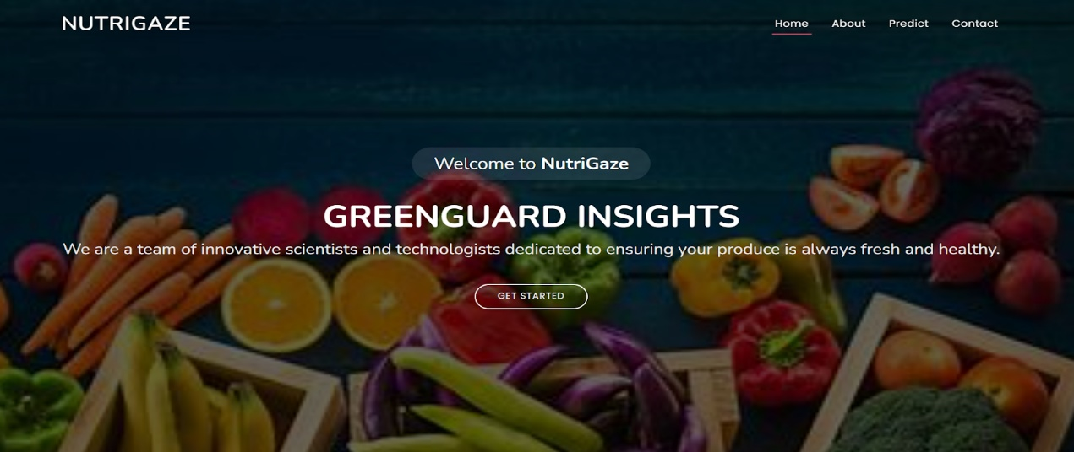
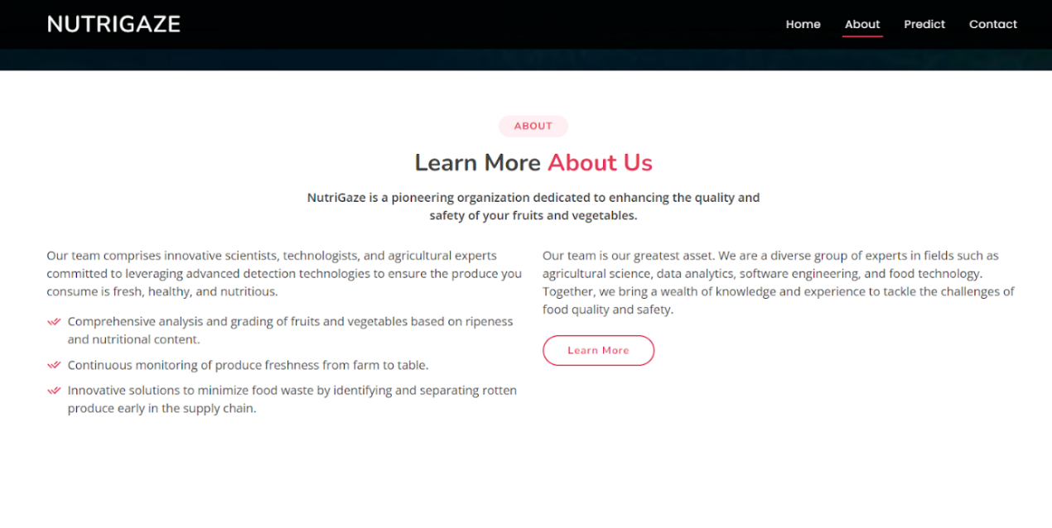
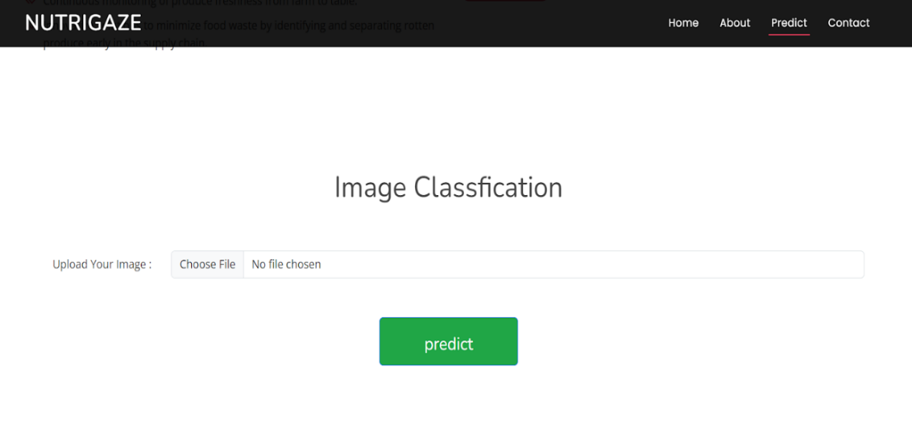
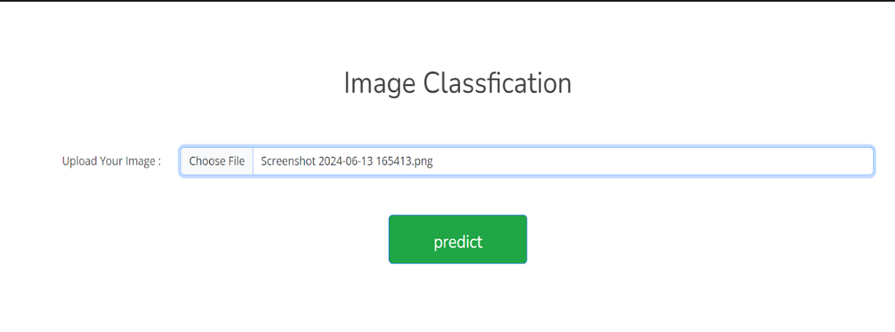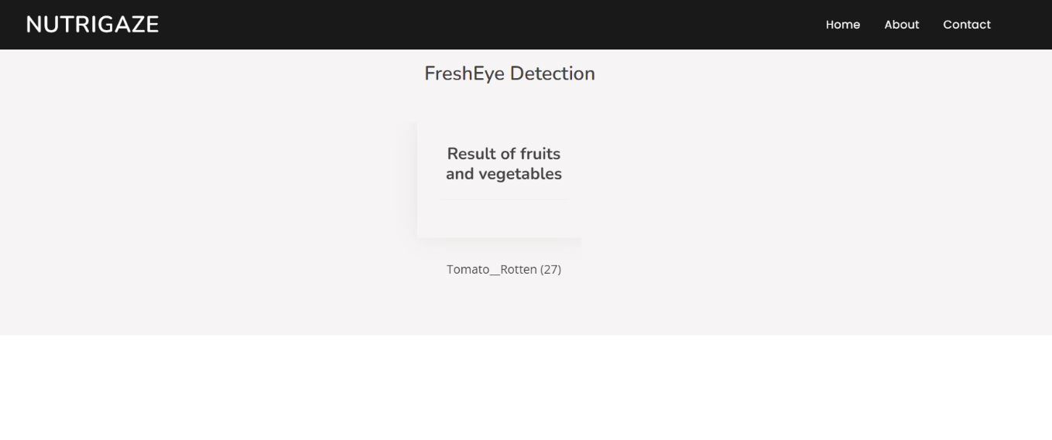

8. ADVANTAGES & DISADVANTAGES

Advantages
- Reduces manual effort.
- High accuracy using transfer learning.
- Saves time in sorting process.
- Minimizes food wastage.
- Scalable for large warehouses.

Disadvantages
- Requires good quality images.
- May misclassify heavily damaged items.
- Dependent on dataset quality.

9. CONCLUSION
Smart Sorting successfully demonstrates the application of Transfer Learning in image classification for identifying rotten fruits and vegetables. The system improves efficiency, reduces human error, and contributes to better food quality management. The project highlights the effectiveness of deep learning techniques in solving real-world agricultural problems.

10. FUTURE SCOPE
- Multi-class classification for different fruit types.
- Integration with automated conveyor belt systems.
- IoT-based real-time sorting machines.
- Mobile application for farmers and vendors.
- Deployment in supermarkets and warehouses.

11. APPENDIX

GitHub Link :
https://github.com/dharani-73/Smart-Sorting-Transfer-Learning-for-Identifying-Rotten-Fruits-and-Vegetables

Project Demo Link :
"C:\Users\nares\OneDrive\Desktop\Smart-Sorting-Transfer-Learning-for-Identifying-Rotten-Fruits-and-Vegetables-main\VID-20250701-WA0006.mp4"

